

**Faculty of Engineering & Technology**

**Electrical & Computer Engineering Department**

**Computer Networks ENCS3320**

**Project #1**

**------------------------------------------------------------------------------**

Student name: Jihad Anfous Student No. :1200704

Student name: Maryan Qassis Student No. :

Student name:Izzat Ibraheem Student No. :

Instructor: Dr.Abdalkarim Awad

Section: 1 Date: 30/5/2023

* **Part 1:**
* **1.1:**
* **Ping:** it’s a command used to check the response time of a network device by sending a small packet of data to the device and measuring the time it takes to receive a response.
* **Tracert:** it’s a command used to identify the path that is taken by data packets sent between two network devices and show the information of the routing hops along the way.
* **Nslookup:** it’s a command used to query the DNS to obtain information about the IP address associated with a specific hostname.
* **Telnet:** it’s a command that allows users to remotely connect to a device over a network.
* **1.2:**
* **Ping 100.87.223.20 (Samsung Galaxy Note 10+):**

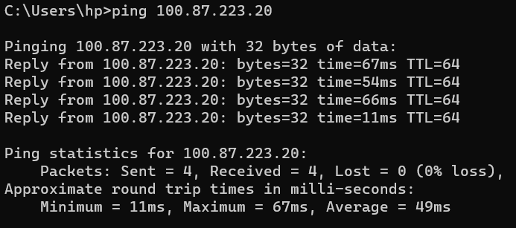

The laptop has sent four packets to the phone that has the following IP address: **100.87.223.20**  then the laptop has started the timer to measure how much time is needed to receive response for every packet sent.

Packet #1 took 67ms to receive it’s response.

Packet #2 took 54ms to receive it’s response.

Packet #3 took 66ms to receive it’s response.

Packet #4 took 11ms to receive it’s response.

* **Ping** [**www.harvard.edu**](http://www.harvard.edu)**:**

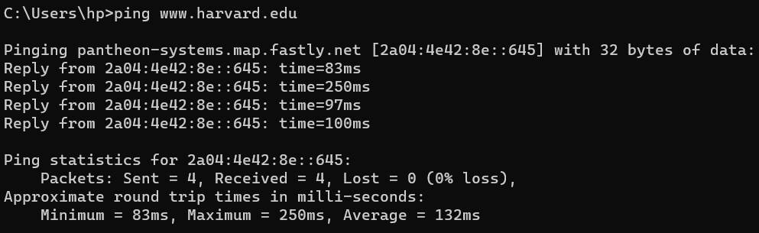

The laptop has sent four packets to Harvard server and started a timer to measure

how much time does take to receive the response for every packet.

Packet #1 took 83ms to receive it’s response.

Packet #2 took 250ms to receive it’s response.

Packet #3 took 97ms to receive it’s response.

Packet #4 took 100ms to receive it’s response.

* **Tracert** [**www.harvard.edu**](http://www.harvard.edu)

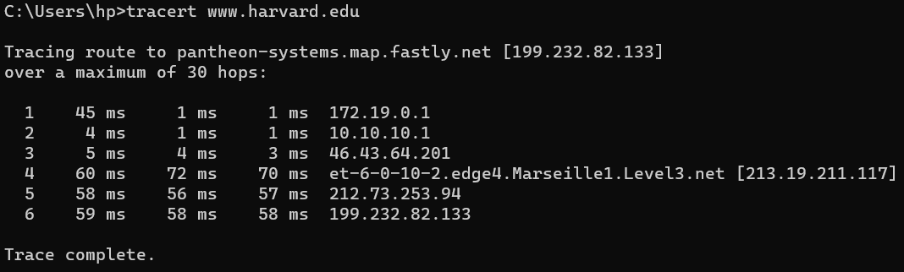

The laptop has sent a packet to Harvard server to see what path will it take in it’s route (what routers will it go through). As we see it has gone through six routers, every router IP is given on the last column from the right.

* **Nslookup** [**www.harvard.edu**](http://www.harvard.edu)

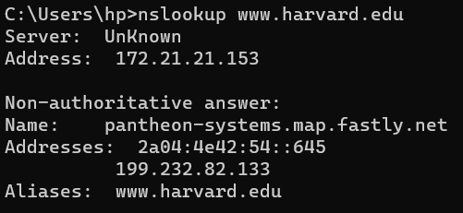

The following information is Harvard server info.